Site Suitability Analysis for Wind Farms North of Beijing

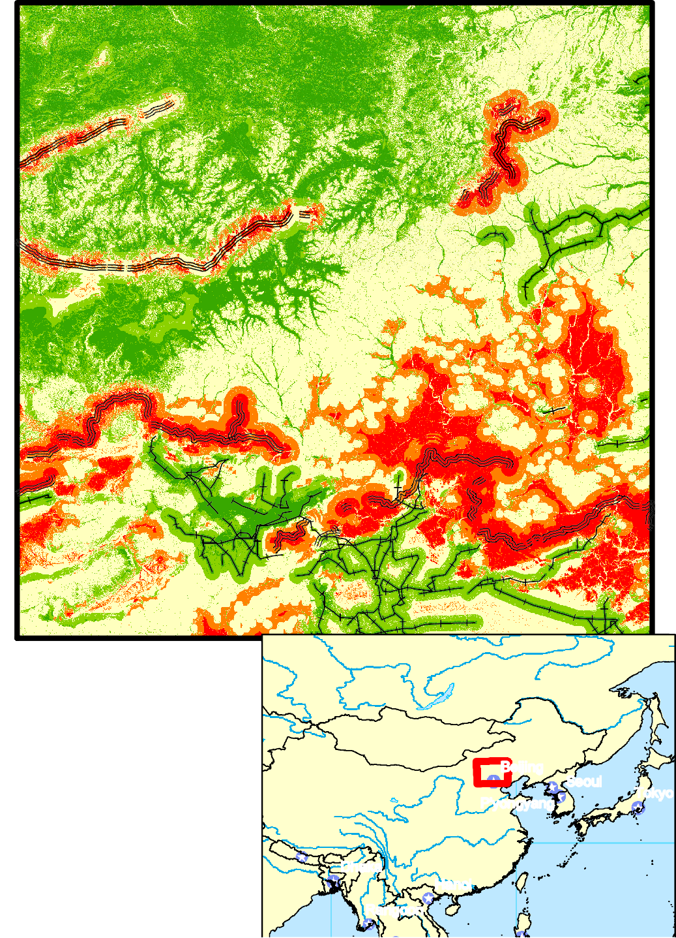Weighted Unweighted

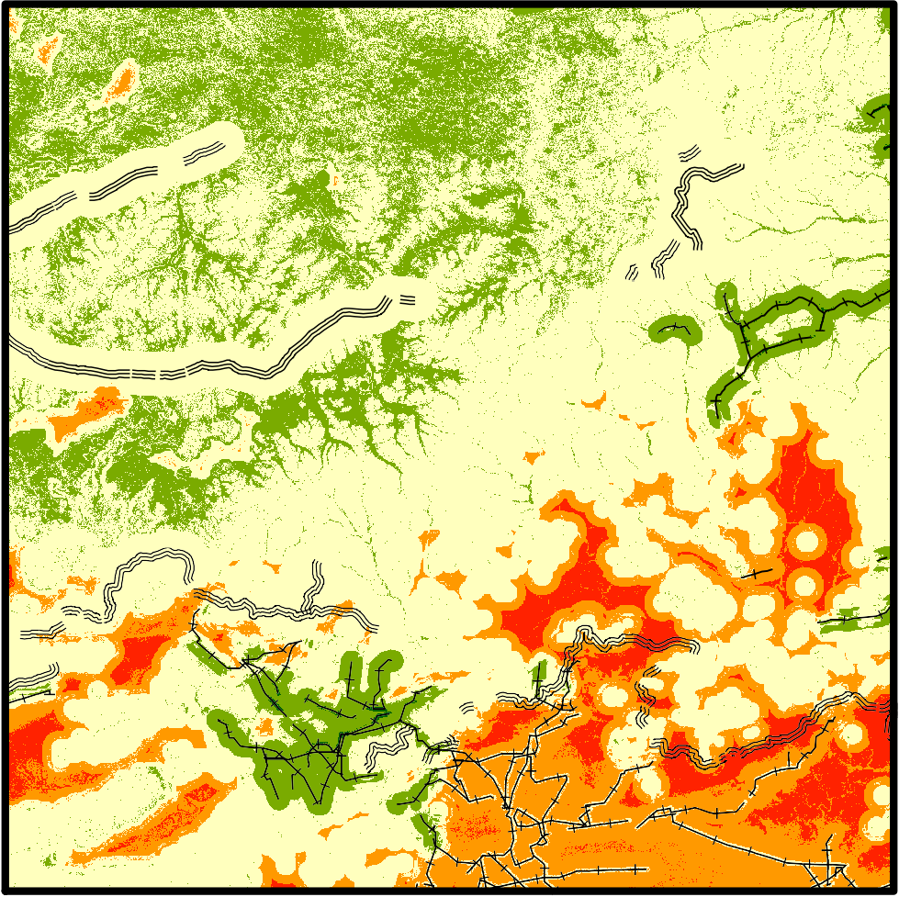

# Suitability

**Additional Features**

These maps show weighted and unweighted analysis of the area north of Beijing, China for a new wind farm.

*60N*

Poor Suitability

Low Suitability

¯

## Great Wall

Powerlines

The analysis was based on four criteria:

1. Wind Speed
2. Slope

 Suitable Good Suitability

Ideal Suitability

1. Distance to Power Lines
2. Distance from the Great Wall

Brian Froeb October 31st, 2018

Dhaka

*30N*

Beijing P'yongyang

Seoul

Tokyo

0 15

30 60 90 120

Miles

Data From: Tufts University M Drive, ERSI, NREL.

Rangoon

*90E*

*120E*

Hanoi